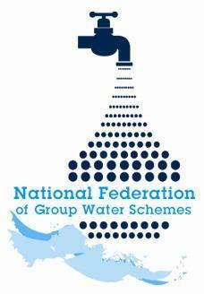

NFGWS Group Water Scheme Excellence Awards 2026
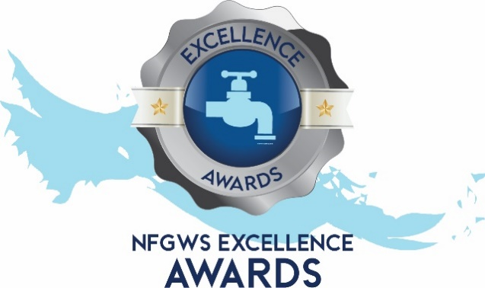

Group Water Scheme Application Form

Instructions to applicants of the Group Water Scheme Excellence Awards
1 | Applications must be completed using the templates provided. All applicants must complete the 'GWS Details' section and select the categories being entered.
2 | Applicants must fully complete the form for the relevant category/categories they wish to enter.
3 | GWS can apply under as many categories as they wish.
4 | Applicants are encouraged to include supporting documentation with their application. This can include pictures, reports, data, screenshots etc. Pictures should be submitted in JPEG format and documents in PDF format.
5 | Entrants should note the closing date of Monday 22nd of June 2026 @ 5pm. Completed applications must be emailed to your local development officer or posted to NFGWS, Esker House, Patrick Street, Tullamore, Co. Offaly.
6 | GWSs applying must be NFGWS affiliated.
7 | Repeat Overall Winners: Overall winners of any category will be excluded from winning in that category (only) for the subsequent two annual award programmes.

Group Water Scheme Details
Name of GWS
GWS address
GWS county

Main Contact
Name of applicant
Contact email of applicant
Mobile phone number

Categories the GWS is interested in applying for | Tick Box (‘X’)
All categories
GWS Ethos and Volunteerism Award
Water Safety Planning & Quality Assurance
Water Demand Management & Climate Action
Biodiversity Enhancement
Community engagement

Water Safety Planning & Quality Assurance Award
Ensure you include documents/reports/photographs to demonstrate your points

Question 1  Outline how your scheme specifically assesses and manages risks to drinking water quality at each of the 5 Critical Control Points (CCP). |  | Marks Available for Q1  75 total marks
CCP1 – Source catchment/zone of contribution – Assessing and managing risks. |  | 15 marks
Please provide examples of up to three initiatives your GWS has undertaken to assess risks and how you manage those risks, with further details to support your examples, e.g. carrying out a raw water monitoring programme (assess), followed by implementation of mitigation measures (manage).

Initiative 1:

Initiative 2:

Initiative 3:

CCP2 – Abstraction – Assessing and managing risks. |  | 15 marks
Please provide examples of up to three initiatives your GWS has undertaken to assess risks and how you manage those risks, with further details to support your examples, e.g. examining risk of surface water intrusion (assess), followed by installation of well-head protection (manage).

Initiative 1:

Initiative 2:

Initiative 3:

CCP3 – Treatment Plant – Assessing and managing risks. |  | 15 marks
Please provide examples of up to three initiatives your GWS has undertaken to assess and manage risks, with further details to support your examples. e.g. equipment inspection (assess) and installation of alarms and auto changeover for duty standby pumps (manage) OR inspection of DBO monthly status reports (assess) and regular contact with DBO operators and employer’s representatives (manage).

Initiative 1:

Initiative 2:

Initiative 3:

CCP4 – Storage tanks and reservoirs – Assessing and managing risks. |  | 15 marks
Please provide examples of up to three initiatives your GWS has undertaken to assess and manage risks, with further details to support your examples. e.g. water level monitoring (assess) and ensuring adequate contact time (manage).

Initiative 1:

Initiative 2:

Initiative 3:

CCP5 – Distribution network – Assessing and managing risks. |  | 15 marks
Please provide examples of up to three initiatives your GWS has undertaken to assess and manage risks, with further details to support your examples. e.g. regular inspection of infrastructure (assess) and standard operating procedures for repairs (manage).

Initiative 1:

Initiative 2:

Initiative 3:

Question 2  Quality Assurance/Water Safety Planning is a priority for every group water scheme.  Explain how Quality Assurance procedures are documented and planned for through GWS operations and how it is reported and overseen by the GWS board of management. |  | Marks available for Q2  Total 20 marks
2a. Please mark ‘X’ in the table below for up to five of the following initiatives your GWS has undertaken. |  | 5 marks
Initiative | Tick box ‘X’
Record-keeping at each CCP
Standard-operating procedures
Emergency response plans
Use to technology
Staff/board training
Dedicated QA personnel
QA reports presented to GWS meetings
Provision of information to members
Other initiatives/activities – details here:

2b. Please supply any further information on a maximum of five points from above to support your application in the box below. | 15 marks
Point 1:

Point 2:

Point 3:

Point 4:

Point 5:

Question 3  Has your GWS Board completed the NFGWS Online training course ‘Introduction to Group Water Scheme Management and Governance’?  (supporting documentation i.e. Certificate of completion to be included). |  |  | Marks  available for  Q3  5 total marks
Tick Box (‘X)
Yes
No

