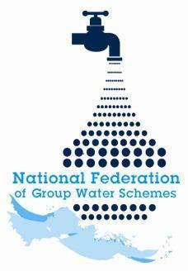

NFGWS Group Water Scheme Excellence Awards 2026
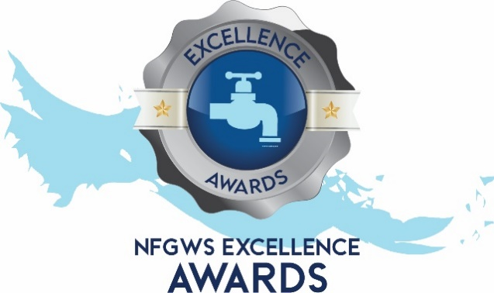

Group Water Scheme
Application Form

Instructions to applicants of the Group Water Scheme Excellence Awards
1 | Applications must be completed using the templates provided. All applicants must complete the 'GWS Details' section and select the categories being entered.
2 | Applicants must fully complete the form for the relevant category/categories they wish to enter.
3 | GWS’s can apply under as many categories as they wish.
4 | Applicants are encouraged to include supporting documentation with their application. This can include pictures, reports, data, screenshots etc. Pictures should be submitted in JPEG format and documents in PDF format.
5 | Entrants should note the closing date of Monday 22nd of June @ 5pm. Completed applications must be emailed to your local development officer or posted to NFGWS, Esker House, Patrick Street, Tullamore, Co. Offaly.
6 | GWSs applying must be NFGWS affiliated.
7 | Repeat Overall Winners: Overall winners of any category will be excluded from winning in that category (only) for the subsequent two annual award programmes.

Group Water Scheme Details
Name of GWS
GWS address
GWS county

Main Contact
Name of applicant
Contact email of applicant
Mobile phone number

Categories the GWS is interested in applying for | Tick Box (‘X’)
All categories
GWS Ethos and Volunteerism Award
Water Safety Planning & Quality Assurance
Water Demand Management & Climate Action
Biodiversity Enhancement
Community engagement

Water Demand Management & Climate Action Award
Ensure you include documents/reports/photographs to demonstrate your points

Question 1  What steps has your GWS taken to understand the impact of climate change on your GWS? | Marks available for Q1  25 total
1a. Please mark ‘X’ in the table below for up to 5 of the following initiatives your GWS has undertaken. | 5 marks
Initiatives | Tick box ‘X’
Completion of an abstraction assessment
Completion of an energy audit
Regular raw water quality monitoring
Installation of well level sensors
Installation of a weather station on the GWS
Analysis of water demand changes
Assessment of key GWS infrastructure for extreme weather-readiness e.g. electricity outages
Participation in NFGWS BECA project
Engagement with other climate/energy related organisations
Other initiatives/activities – details here:

1b. Please supply any further information on a maximum of five points from above to support your application in the box below. |  | 20 marks
Question 2  Describe any climate adaptation measures taken by the scheme to minimise impacts identified in Q1 and build resilience across the GWS supply chain (Catchment, Source, Treatment, Storage, Distribution system) including any steps your group water scheme has taken to reduce its carbon footprint. |  | Marks available for Q2  20 total
2a. Please mark ‘X’ in the table below for up to five of the following initiatives your GWS has undertaken. |  | 5 marks
Initiative | Tick box ‘X’
Securing alternative sources to improve water availability
Installation of renewable energy
Strategic pumping regimes
Pressure management programmes
Network replacement/water conservation projects
Engagement with members/local schools
Minimising environmental impact while laying watermains
Ensuring key GWS infrastructure is generator-ready
Implementation of source protection measures
Other initiatives/activities – details here:

2b. Please supply any further information on a maximum of five points from above to support your application in the box below. |  | 15 marks
Question 3  In the box below, please provide details of GWS water demand and UFW levels on the entire distribution network for 2024. Please express UFW as loss per kilometre (m3/km) and as an overall percentage (please provide documentary evidence e.g. water audit if completed). |  | Marks available for Q3  25 total
(Tips: Include analysis of legitimate demand vs total demand, breakdown of DMAs, night flows, domestic vs non-domestic usage, operational usage etc.)

Answer here:

Question 4  Describe below how the scheme uses data from water audit findings, keeps members informed of water usage and proactively encourages water conservation as part of this process. Please provide specific examples. |  | Marks available for Q4  25 total
(Tips: Detail bulk meters, telemetry, monitoring and technology systems, pressure management practices, leak identification and repair procedures, member engagement etc.)
Answer here:

Question 5  Has your GWS Board completed the NFGWS Online training course ‘Introduction to Group Water Scheme Management and Governance’?  (supporting documentation i.e. certificate of completion to be included). |  | Marks  available for  Q5  5 total
Tick Box (‘X)
Yes
No

