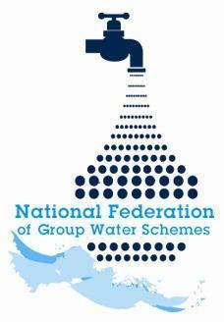

NFGWS Group Water Scheme Excellence Awards 2026
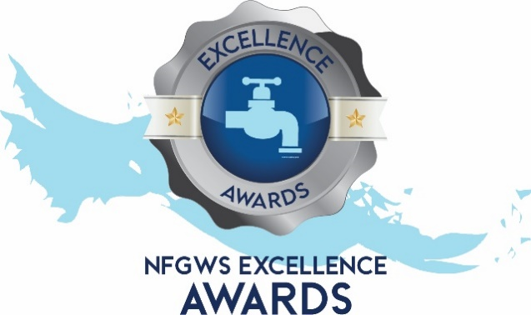

Group Water Scheme
Application Form

Instructions to applicants of the Group Water Scheme Excellence Awards
1 | Applications must be completed using the templates provided. All applicants must complete the 'GWS Details' section and select the categories being entered.
2 | Applicants must fully complete the form for the relevant category/categories they wish to enter.
3 | GWS can apply under as many categories as they wish.
4 | Applicants are encouraged to include supporting documentation with their application. This can include pictures, reports, data, screenshots etc. Pictures should be submitted in JPEG format and documents in PDF format.
5 | Entrants should note the closing date of Monday 22nd of June 2026 @ 5pm. Completed applications must be emailed to your local development officer or posted to NFGWS, Esker House, Patrick Street, Tullamore, Co. Offaly.
6 | GWSs applying must be NFGWS affiliated.

Group Water Scheme Details
Name of GWS
GWS address
GWS county

Main Contact
Name of applicant
Contact email of applicant
Mobile phone number

Categories the GWS is interested in applying for | Tick Box (‘X’)
All categories
GWS Ethos and Volunteerism Award
Water Safety Planning & QA
Water Management & Climate Action
Biodiversity Enhancement
Community engagement
GWS Ethos and Volunteerism Award

This award recognises outstanding examples of GWS ethos and volunteerism. We invite all GWS members to submit an example of activities that exemplifies these values.

It provides another opportunity for your GWS to be recognised for its contributions and win a national award.

Examples of qualifying activities include, but are not limited to:
- Efforts during storm events
- Collaborations with other local groups
- Recruitment of board officers
- Initiatives focused on inclusion and youth engagement
- Other impactful projects or instances where volunteers
significantly supported GWS efforts

We look forward to hearing your stories and celebrating the remarkable work and dedication of our GWS community.

Please note…
- All examples must be regarding voluntary efforts
- This category will be limited to a maximum of 15 winners and will be allocated on a first-come, first-served basis.
- A GWS may nominate only one person.
- In the interest of fairness, GWS’s who nominated someone in 2025 are not eligible to apply this year.
- GWSs applying must be NFGWS affiliated.

Tell your story below:

