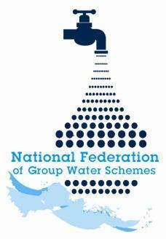

NFGWS Group Water Scheme Excellence Awards 2026
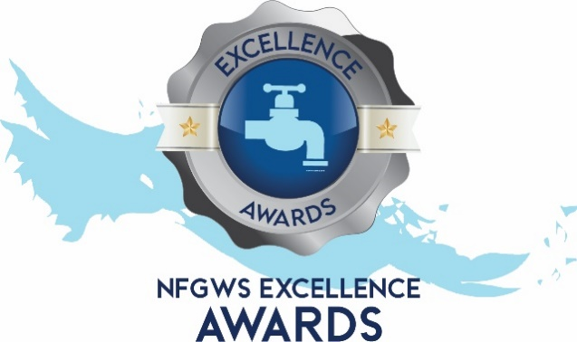

Group Water Scheme Application Form

Instructions to applicants of the Group Water Scheme Excellence Awards
1 | Applications must be completed using the templates provided. All applicants must complete the 'GWS Details' section and select the categories being entered.
2 | Applicants must fully complete the form for the relevant category/categories they wish to enter.
3 | GWS can apply under as many categories as they wish.
4 | Applicants are encouraged to include supporting documentation with their application. This can include pictures, reports, data, screenshots etc. Pictures should be submitted in JPEG format and documents in PDF format.
5 | Entrants should note the closing date of Monday 22nd of June 2026 @ 5pm. Completed applications must be emailed to your local development officer or posted to NFGWS, Esker House, Patrick Street, Tullamore, Co. Offaly.
6 | GWSs applying must be NFGWS affiliated.
7 | Repeat Overall Winners: Overall winners of any category will be excluded from winning in that category (only) for the subsequent two annual award programmes.

Group Water Scheme Details
Name of GWS
GWS address
GWS county

Main Contact
Name of applicant
Contact email of applicant
Mobile phone number

Categories the GWS is interested in applying for | Tick Box (‘X’)
All categories
GWS Ethos and Volunteerism Award
Water Safety Planning & Quality Assurance
Water Demand Management & Climate Action
Biodiversity Enhancement
Community engagement

Community Engagement Award

Ensure you include documents/reports/photographs to demonstrate your points

Question 1  What initiatives has your GWS undertaken to engage with members and the wider community? | Marks available for Q1  40 total
1a. Please mark ‘X’ in the table below for up to five of the following initiatives your GWS has undertaken. | 10 marks
Initiative | Tick box ‘X’
Source protection works
Farm visits
School visits
Work with local groups (e.g. Tidy Towns, GAA etc)
Water conservation project
‘I’ve planted a tree’ project
‘Let it bee’ project
New initiatives to promote meeting attendance
Engagement with Volunteer Centre
Photography completion
Other initiatives/activities – details here:

1b. Please supply any further information on a maximum of five points from above to support your application in the box below. |  |  |  | 30 marks
Point 1:

Point 2:

Point 3:

Point 4:

Point 5:

Question 2  How does your GWS communicate with your community? | Marks available for Q2  40 total
2a. Please mark ‘X’ in the table below for up to five of the following activity your GWS has undertaken. | 10 marks
Methods of communication | Tick box ‘X’
Postal
Email
Phone calls
Text message
Website
Videos
Newsletters/information leaflets
Signage at source
Signage throughout catchment
Water refill station
Other initiatives/activities – details here:

2b. Please supply any further information on a maximum of five points from above to support your application in the box below. |  | 30 marks
Point 1:

Point 2:

Point 3:

Point 4:

Point 5:

Question 3  In the box below, explain the steps being taken to ensure the board is as representative as possible of the membership with particular emphasis on encouraging a diverse age profile and greater gender balance.  Examples may include letters of invitation, open days, succession planning by board, interaction with community groups, etc. |  |  | Marks available for Q3  15 total
Answer here:

Question 4  Has your GWS Board completed the NFGWS Online training course ‘Introduction to Group Water Scheme Management and Governance’?  (supporting documentation i.e. certificate of completion to be included). |  |  |  | Marks  available for Q4  5 total
Tick Box (‘X)
Yes
No

