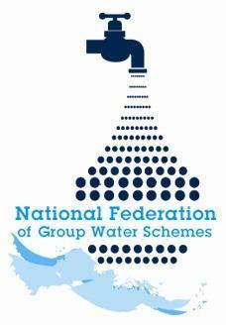

NFGWS Group Water Scheme
Excellence Awards 2026

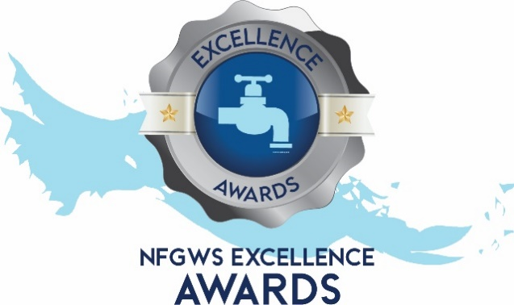

Group Water Scheme Application Form

Instructions to applicants of the Group Water Scheme Excellence Awards
1 | Applications must be completed using the templates provided. All applicants must complete the 'GWS Details' section and select the categories being entered.
2 | Applicants must fully complete the form for the relevant category/categories they wish to enter.
3 | GWS can apply under as many categories as they wish.
4 | Applicants are encouraged to include supporting documentation with their application. This can include pictures, reports, data, screenshots etc. Pictures should be submitted in JPEG format and documents in PDF format.
5 | Entrants should note the closing date of Monday 22nd of June 2026 @ 5pm. Completed applications must be emailed to your local development officer or posted to NFGWS, Esker House, Patrick Street, Tullamore, Co. Offaly.
6 | GWSs applying must be NFGWS affiliated.
7 | Repeat Overall Winners: Overall winners of any category will be excluded from winning in that category (only) for the subsequent two annual award programmes.

Group Water Scheme Details
Name of GWS
GWS address
GWS county

Main Contact
Name of applicant
Contact email of applicant
Mobile phone number

Categories the GWS is interested in applying for | Tick Box (‘X’)
All categories
GWS Ethos and Volunteerism Award
Water Safety Planning & Quality Assurance
Water Demand Management & Climate Action
Biodiversity Enhancement
Community Engagement

Biodiversity Enhancement Award
Ensure you include documents/reports/photographs to demonstrate your points

Question 1  What steps has your GWS taken to implement biodiversity enhancement on your GWS? | Marks available for Q1  35 total
1a. Please mark ‘X’ in the table below for up to five of the following initiatives your GWS has undertaken. | 10 marks
Management practices | Tick box ‘X’
GWS signed up to the All-Ireland pollinator plan
GWS adopted a motion to become biodiversity friendly at an AGM/board level
GWS appointed a responsible person for biodiversity enhancement
A biodiversity action plan completed
Biodiversity training completed
GWS stopped using pesticides
GWS started to make its own sites pollinator-friendly
A rainwater planter or pollinator planters installed
Other initiatives/activities – details here:

1b. Please supply any further information on a maximum of five points from above to support your application in the box below. |  | 25 marks
Point 1:

Point 2:

Point 3:

Point 4:

Point 5:

Question 2  What community activities has your GWS undertaken to promote biodiversity? | Marks available for Q2  30 total
2a. Please mark ‘X’ in the table below for up to five of the following initiatives your GWS has undertaken. | 10 marks
Activities | Tick box ‘X’
Members have received the gardening for biodiversity book or other biodiversity advice information
GWS has carried out the 'I’ve planted a tree' project
GWS has carried out the 'Let it bee' project
Schools connected to the GWS network visited and received the 'All about Water' curriculum
GWS branded biodiversity signage erected
Other initiatives/activities – details here:

2b. Please supply any further information on a maximum of five points from above to support your application in the box below. |  |  | 20 marks
Point 1:

Point 2:

Point 3:

Point 4:

Point 5:

Question 3  Has the GWS implemented source protection measures that have co-benefits associated with enhancing biodiversity? |  | Marks available for Q3  30 total
3a. Please supply any further information on a maximum of four initiatives to support your application in the box below. |  | 30 marks
Point 1:

Point 2:

Point 3:

Point 4:

Question 4  Has your GWS Board completed the NFGWS Online training course ‘Introduction to Group Water Scheme Management and Governance’?  (supporting documentation i.e. certificate of completion to be included). |  | Marks  available for Q4  5 total
Tick Box (‘X)
Yes
No

